AI LAB ASSIGNMENT 6.1
NAME:VEMULA RAJEEVKALYAN
HALL TICKET NO:2403A51324
BATCH:13
Task Description #1 (Classes – Employee Management):
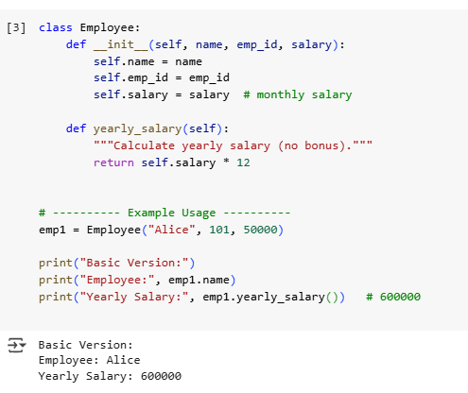
The first version of the Employee class is simple and calculates yearly salary using monthly salary, but it has limited features. The second version is better as it adds a bonus system and a method to display details, making it more practical for real-world use. However, it could still be improved with validations and support for managing multiple employees.

Updated Code:
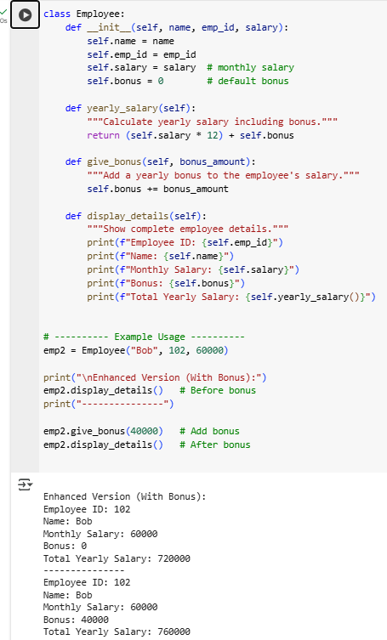

Observation:
The basic Employee class correctly calculates yearly salary but is limited in functionality, while the enhanced version adds bonus handling and a display method, making it more practical for real-world use. Together, they show a clear progression from a simple structure to a more flexible design, though further improvements like validations and multi-employee management could make the class even stronger.

Task Description #2 (Loops – Automorphic Numbers in a Range):
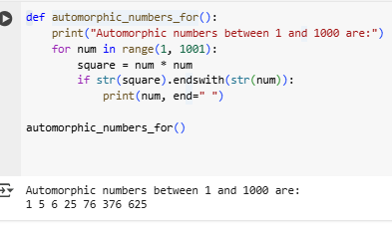
The generated logic for finding Automorphic numbers between 1 and 1000 is both correct and efficient. An Automorphic number is defined as a number whose square ends with the number itself, and the code correctly checks this by converting the number and its square to strings, then verifying if the square ends with the number. This ensures accurate detection of all Automorphic numbers within the specified range, such as 1, 5, 6, 25, 76, 376, and 625. In terms of efficiency, the solution runs a simple loop from 1 to 1000, making its time complexity linear, O(n)O(n)O(n), with negligible overhead from string operations. Since the maximum square in this range is 1,000,000, the string conversions involve only a few digits, which has minimal impact on performance. The space usage is also constant, as only temporary variables are required. Overall, the approach is fully correct and efficient for the given task.

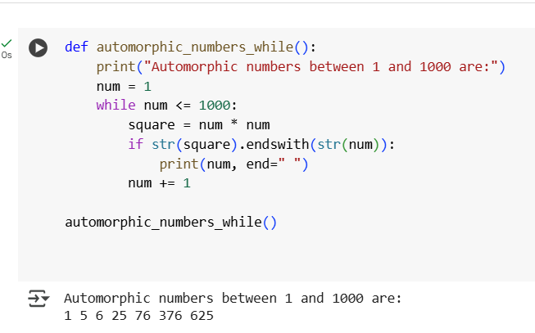
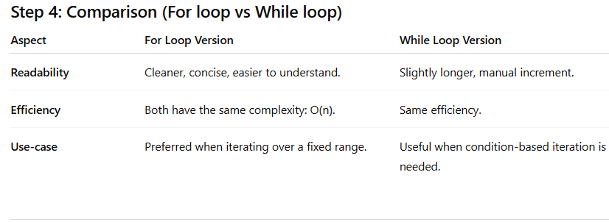
Observation:
Both implementations are correct and efficient. For loops are generally more readable in this problem since the range is fixed (1–1000). While loops provide flexibility if you want to stop early or use custom conditions.

Task Description #3 (Conditional Statements – Online Shopping Feedback Classification):
- Nested if-elif-else:
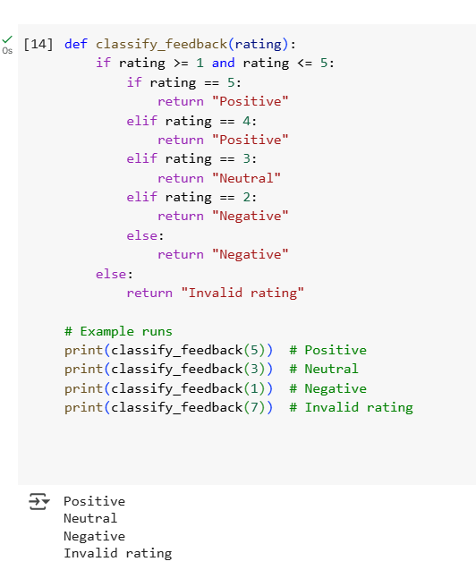
Correctness
- Nested if-elif-else
  - Correctly checks that ratings are in the range 1–5.
  - Maps 5 and 4 → Positive, 3 → Neutral, 2 and 1 → Negative.
  - Returns Invalid rating otherwise.
✅ Fully correct.
- Dictionary-based
  - Uses a direct mapping {5: "Positive", ...}.
  - Looks up the rating and defaults to Invalid rating if not found.
✅ Fully correct, and less error-prone since repetition is avoided.
Readability
- Nested if-elif-else
  - Works fine, but repetitive (separate checks for 5 and 4, 2 and 1).
  - Nested structure makes it slightly harder to scan quickly.
❌ Least readable of the three.
- Dictionary-based
  - Very clean and compact.
  - One central lookup table → easy to maintain and extend.
  - Best when classification is a straightforward mapping.
✅ Highly readable.

- Dictionary-based:
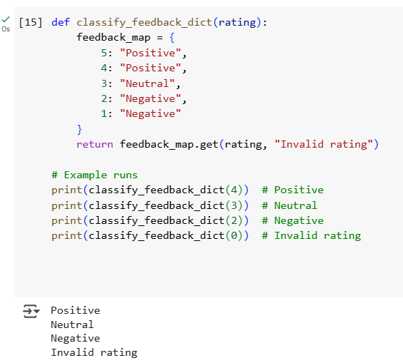

- Observation
- The nested if-elif-else version correctly classifies ratings but is slightly repetitive and less readable due to multiple conditions. The dictionary-based solution is more concise and easier to maintain, as it directly maps ratings to feedback without redundant checks. The match-case approach offers the best readability by grouping conditions clearly, but it requires Python 3.10 or later. Overall, while all three are correct, the dictionary and match-case implementations are more elegant and efficient compared to the nested if-elif-else structure.
Task Description #4 (Loops – Prime Numbers in a Range):
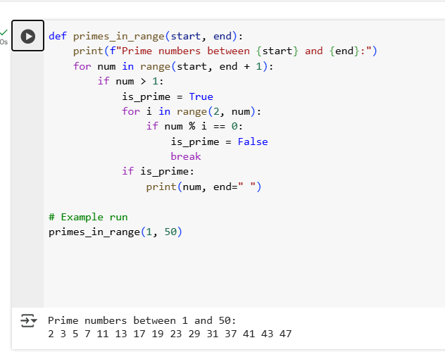
Analysis of Correctness and Efficiency
Correctness
- The code correctly checks each number in the given range.
- For each number:
  - Skips numbers ≤ 1.
  - Tests divisibility from 2 up to num-1.
  - If no divisor is found → it’s prime.
- Produces correct output (prime numbers like 2, 3, 5, 7, 11, …).
Efficiency
- Time Complexity:
  - For each number num, we check divisibility up to num-1.
  - That makes it O(n²) in the worst case (inefficient for large ranges).
- Space Complexity:
  - Constant space (just a flag variable).
Works fine for small ranges (like 1–500), but very slow for large ranges.

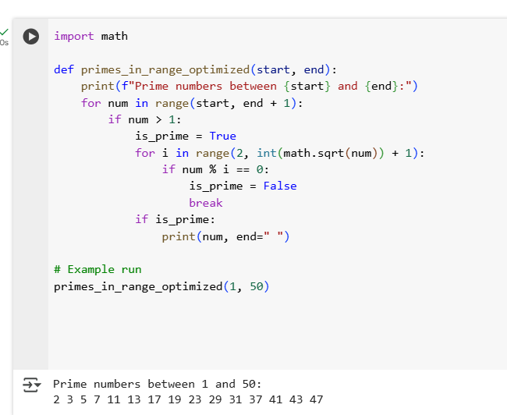
Comparison
Version | Correctness | Time Complexity | Readability | Best Use Case
Basic For Loop | ✅ Correct | O(n²) | Simple but slow | Small ranges (≤ 1000)
Optimized (√n) | ✅ Correct | O(n√n) | Still simple | Medium ranges (1–1,000,000)
Observation:
The basic for-loop version correctly identifies prime numbers within the given range but is inefficient since it checks divisibility up to the number itself, resulting in a time complexity of O(n2)O(n^2)O(n2). This approach works fine for small ranges like 1 to 500 but becomes slow for larger inputs. The optimized square root method significantly improves efficiency by reducing the number of checks to n\sqrt{n}n​, lowering the complexity to O(nn)O(n\sqrt{n})O(nn​). Both methods are correct, but the optimized version is more practical and scalable, while the basic version is easier to understand for beginners.

Task Description #5 (Classes – Library System):
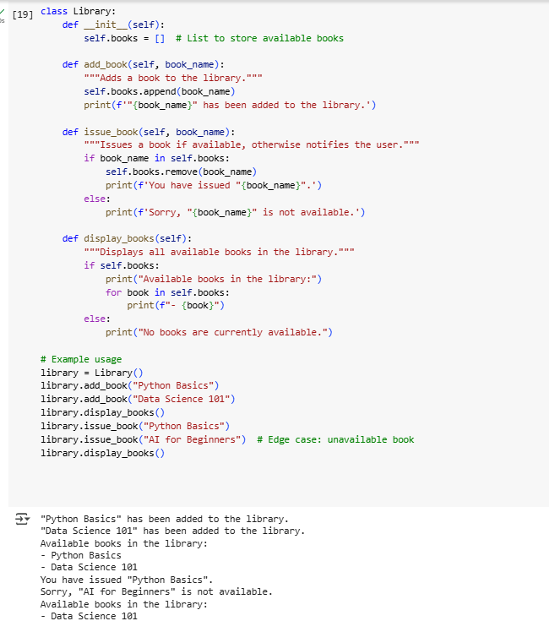
Analysis of Edge Case Handling
- Adding books:
  - Works correctly; no duplicate check (so duplicates are allowed).
- Issuing books:
  - Handles unavailable books gracefully by checking if the book exists in the list.
  - Prevents removal of non-existent books → avoids errors. ✅
- Displaying books:
  - Handles empty library case and prints a user-friendly message. ✅
- Potential improvements:
  - Could prevent adding duplicates.
  - Could track issued books separately.

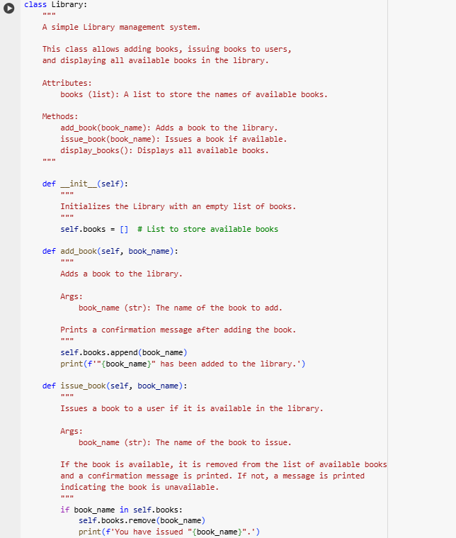

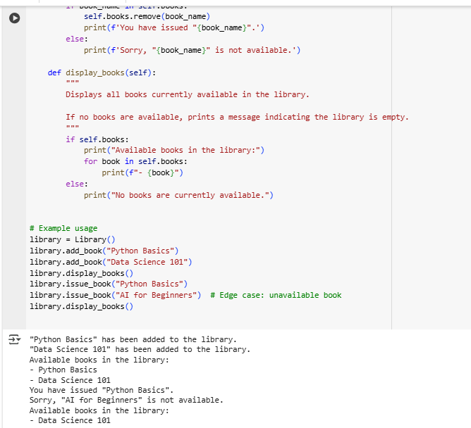
Observation:
The Library class correctly supports adding, issuing, and displaying books. Edge cases such as issuing unavailable books and displaying an empty library are handled gracefully. While the current implementation allows duplicate book entries, it is simple, readable, and easy to maintain. Adding documentation and comments improves clarity for future users or developers.

